B737 PRO LITE

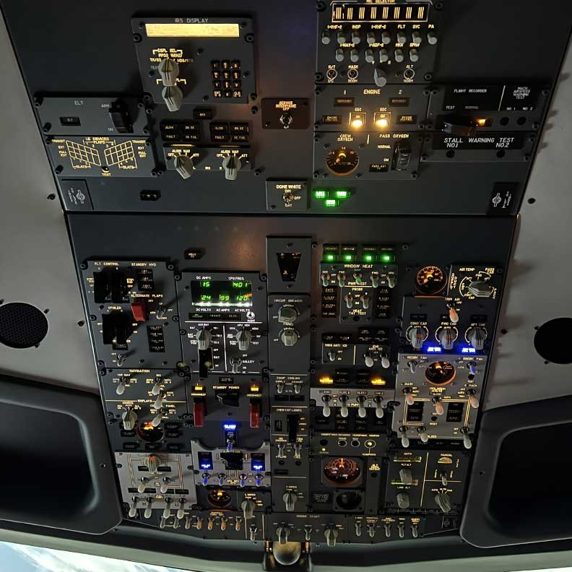

Full-sized

shell

Our simulators come in a 1:1 scale shell, built out of aluminium and high-quality resins for a perfect look and feel. Cockpit windows, cupholders, window handles, J-rail captain, and rst of cer seats…



Tested and validated

Our simulators are tested and validated by our technical and pilot crews before shipping to your location, for a smooth installation and optimal experience.

Real-life procedures

Procedures in the simulator stick to the real-life daily routine of airline pilots. Start the APU, engines, setup your ight plan, and all other systems using real-life checklists and procedures.

The best ROI for your simulator.

Because your simulator is a tool for performance, we have developed unique technologies to make sure you get the best ROI on your investment.

Complete Forward and Aft Overhead with breakers.

Use our simulator for any situation you would like with the completely functional and interfaced overhead that we provide. Korry replica switches, IRS panel, re panel, Electrical, Hydraulics, Fuel, and emergency systems are all realistically programmed.

**B737 PRO LITE**

The best ROI for your simulator.

* B737 Pro Shell & Cockpit
* Professional Licences
* Calculators & Projection System
* Mobile Instructor Station
* Delivery & Installation within Europe included
* 5 Hours of Onsite Training
* HQ 220° Projection Screen
* Worldwide Shipping & Installation (extra)
* Pro Rudders
* Electrical Seats
* Certification to a FNPTII MCC EASA Simulator

**B737 Pro Plus**

Getting close to the real deal.

* B737 Pro Shell & Cockpit
* Pro Rudders & Electrical Seats
* Professional Licences
* Calculators & Projection System
* HQ 220° Projection Screen
* Rear position Instructor Station Setup with mobility
* 10 Hours of Onsite Training
* Worldwide delivery & installation included
* 1 Year of updates included
* Certification to a FNPTII MCC EASA Simulator

Email: sales@kambillsystems.com or service@kambillsystems.com

**Office Address: -Kambill Systems Private Limited**

**202, Aggarwal Corporate Heights, Netaji Subhash Place, Delhi=110034, INDIA.**

**Tel: +91-11-4903 2678 | +91-9650448007**